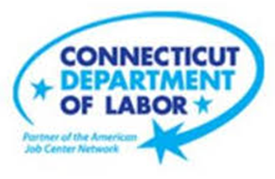

**NEW WEEKLY JOB POSTINGS FROM   
HELP WANTED ONLINE  
Office of Research**

**Week Ending March 12th, 2022: Weekly Ads Remain over 9,000 for Second Week in a Row**  
WETHERSFIELD, March 18th, 2022 – During the week ending March 12th, 2022, there were 9,470 new postings, down 3,239 new ads from the March 5th series high of 12,709 new ads. Though down 25% from last week, the week ending March 12th was the 8th highest new ad count during the pandemic period and 30% above a year ago. A large share of that over the week decline is the result of shifts within Health Care & Social Assistance, which accounted for over 50% of the total drop. That industry shift was heavily influenced by a one-week blip in new ads at Hartford Healthcare, which rose to almost 2,000 during the week ending March 5th or more than 34% of total new ads increase that week. During the most recent week, that employer had 537 new ads, which amounts to 45% of the 3,239 total decline over the week. Other industries with large shares of the total decline include Finance & Insurance and Retail trade, respectively with 7% and 6% of the over the week decline. The weekly swings shown below illustrate the inherent volatility of the weekly new ad series, while also showing that the monthly averages of weekly new ads have been at or above 5,900 since March 2021.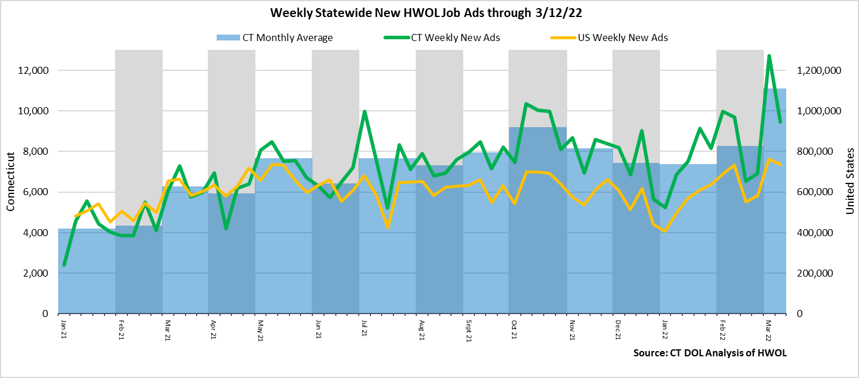

**Industries** with the most new postings include Health Care & Social Assistance, Finance & Insurance, and Manufacturing.

**Occupations** with the most new postings include Registered Nurses, Retail Salespersons, and Heavy & Tractor-Trailer Truck Drivers.

**Employers** with the most new postings include Hartford Healthcare, Aya Healthcare, Yale-New Haven Health System.

**The three industries with the most new job postings where:**

* **Health Care & Social Assistance** (2,258 new postings, -43% over the week)
* **Finance & Insurance** (797 new postings, -22% over the week)
* **Manufacturing** (681 new postings, -12% over the week)

   
 17 industries had job posting decreases over the week and 4 had increases. The 17 decreasing industries fell by a combined 3,444 new ads over the week, with half that drop occurring in Health Care & Social Assistance. That industry was driven by declines at Hartford Healthcare, which had an uncharacteristic one-week new ad increase a week ago. All but two of the 17 decreasing industries fell by 10% or more, 11 fell by 20% or more, and 5 fell by over 40%. Most industries were up over four weeks, with the largest increases occurring within Health Care & Social Assistance (+728 new ads), Educational Services (+343 new ads), and Manufacturing (+145 new ads).  
  
 For more information on total job ads by industry for Connecticut and its labor market areas, see the monthly report available here: <https://www1.ctdol.state.ct.us/lmi/hwol.asp>

**New Job Postings by Occupation**



**The occupations with the most new postings were:**

* Registered Nurses (829 new postings, -53% over the week)
* Retail Salespersons (248 new postings, -22% over the week)
* Heavy and Tractor-Trailer Truck Drivers (184 new postings, -58% over the week)

**Employers with the Most New Job Postings**

Employers with the most new job postings during the week were mostly in Healthcare, Finance & Insurance, and Retail Trade. The 25 employers shown above account for 20 percent of all new ads. Among the top 25 employers, 14 had over the week ad increase and 11 had decreases. With the exception of Hartford Healthcare, most employers had over the week change of less than 100 new ads. Hartford Healthcare had an over the week decrease of 1,459 new ads from about 2,000 new ads last week to 537 during the week ending March 12th. This one-week jump is uncharacteristic for that employer, which averaged 205 new ads per week over the past year. Over four weeks, 22 of 25 employers shown above had increases. The largest over four weeks were Hartford Healthcare (+339 new ads), Aya Healthcare (+157 new ads), and Capital One (+92 new ads).  
   
**What is HWOL?**The **Conference Board Help Wanted Online**® Data Series (HWOL) measures the number of new, first-time Online job postings and jobs reposted from the previous month for over 16,000 Internet job boards, corporate boards and smaller job sites that serve niche markets and smaller geographic areas. To view more HWOL data, go to: <https://www1.ctdol.state.ct.us/lmi/hwol.asp>